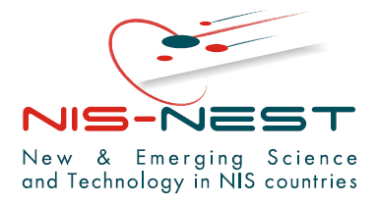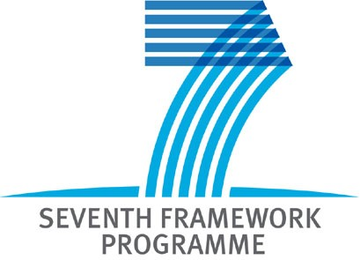

NIS-NEST Workshop on FP7 participation and proposal preparation
Minsk, 29 February 2008

REGISTRATION FORM

Name
Surname
Address
Region
Country
Email
Phone
Organisation_name
Profession/ scientific domain-fields of expertise
Position
Your FP7 research area  (please mark in Bold)
  Health
  Food, agriculture and biotechnology
  Information and communication technologies
  Nanosciences, nanotechnologies, materials and new production technologies
  Energy
  Environment including climate change
  Transport including aeronautics
  Socio-economic sciences and the humanities
  Security
  Space
  Specific Programme Ideas to support basic, frontier research
  Specific Programme People
  Research Infrastructures
  Research for the benefit of SMEs
  Regions of knowledge and support for regional research-driven clusters
  Research potential of Convergence Regions
  Science in Society
  Support to the coherent development of research policies
  Activities of International cooperation
Years of experience of participation in EU projects
Request for further information on NIS-NEST project activities (Y/ N)

