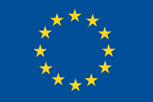
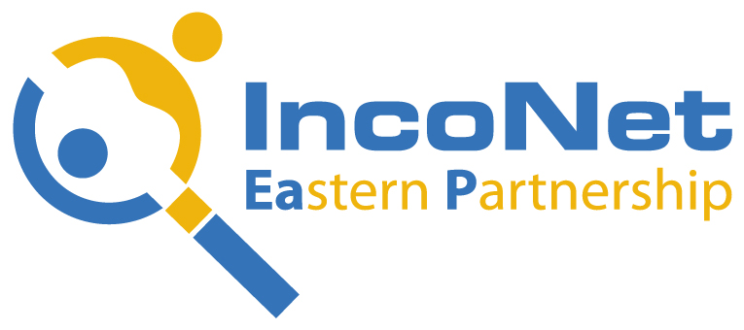 |  |  |  | 

EU-Eastern Partnership STI Cooperation in Addressing Energy Research and Innovation
Policy Stakeholders Conference in Minsk, 12 - 13 October 2015
Venue: Renaissance Hotel, Praspyekt Dzyarzhynskaha 1Е, Minsk

DRAFT PROGRAMME

12 October 2015:

09:00-09:30 Registration

09:30-10:00 Opening Session

Welcome addresses ( 5 min/speaker)
Representatives (3-4 speakers) from Belarus: Director or Head of Department level, from the sectoral ministries dealing with the Energy/policy makers

Thierry Devars, Policy Officer, Research and Innovation Directorate General of the European Commission (tbc)

George Bonas, Scientific Coordinator of IncoNet EaP, Managing Director of CeRISS

10:00-11:30 Session I: International Policies, Initiatives and Programmes on Energy

Moderator:
Rapporteur: Gorazd Weiss, ZSI

- Presentation, Thierry Devars, Policy Officer, Research and Innovation Directorate General of the European Commission (tbc)

- Important energy research related issues at the EU level, Karina Firkaviciute, Policy Officer, Policy Officer, Research and Innovation Directorate General of the European Commission (tbc)

- The Role of the EaP Panel in Promoting Research and Innovation in the EaP Countries, Zygmunt Krasinski, IPPT-PAN, representative of the EaP Panel on Research and Innovation

- Energy Research and Innovation through South-South Cooperation, Mr Adam Rogers, Senior Advisor and Head of Unit of the UNDP Geneva Office

- Best Policy Practices for Promoting Energy Efficiency in the UNECE Region, Mr Oleg Dzioubinski, Sustainable Energy Division Director, UNECE

Q&A (10 min)

11:30-12:00 Coffee break

12:00-13:30 Session I: continued

Moderator:
Rapporteur: Hendrik Meurs, DLR

- Energy Efficiency Policies in EU-Eastern Partnership countries, Mr Steivan Defilla Director, Energy Charter Secretariat

- Energy Efficiency Act of Austria, DI Gabriele Brandl, Scientific Employee Austria Energy Agency

- Presentation on xxx, Ms Olga Yeriomina, Senior Banker, Power&Energy Utilities, EBRD

- KIC InnoEnergy Presentation, Mr. Robert Gohla, Representative of KIC InnoEnergy Project, Coordinator of Knowledge Transfer Community to bridge the gap between research, innovation and business creation – NoGAP Project

- Support for Advanced Biofuels Stakeholders, Mr Peter Canciani, Project Manager at CEI Executive Secretariat, European Biofuels Technology Platform

13:30-14:30 Lunch

14:30-18:30 Session II: Good practice examples of projects and studies involving the EaP countries

Moderator:
Rapporteur: Mariam Keburia, SRNSF

14:30-16:00 Panel I: Presentations of projects focusing on energy

- Bibliometric Analysis of EU-EaP joint publications in Energy, Hanna Scheck, Project Manager ZSI

- Synergies between various EU-Instruments related to the energy issues, Dr. Piotr Swiatek, Representative of German National Contact Point for Energy in H2020

- Presentation on xxx , Mr George Skevis, Vice-Chair of the H2020 European Project SMARTCATS

- Energy democracy and the use of renewable energy resources, Ms Alexia Timotheou, Environment & Sustainable Development Expert of ICBSS

- Turkish renewable energy vision 2023 and Applied technological research activities of TUBITAK MRC Energy Institute, Dr. Alper SARIOGLAN

Q&A (15 min)

16:00-16:30 Coffee break

Moderator:
Rapporteur: Tigran Arzymanyan, NAS-RA

16:30-18:00 Panel II: Presentations of EaP countries on energy

- Low carbon technology for energy-carriers production, Prof Islam Mustafayev, Head of Laboratory Energy Saving Processes, Institute of Radiation problems National Academy of Sciences, Hydrogen Energy OR General picture of renewable energy projects in Azerbaijan or presentation of several specific projects, Aydin Huseynov, Head of ICT and innovations economics division, Research Institute for Economic Studies,State University of Economics

- EU Covenant of Mayors Initiative and its progress in Eastern Partnership countries, Mr George Abulashvili, Director of NGO “Energy Efficiency Centre Georgia OR Using Geothermal Deposits of Georgia As Renewable Energy Source, Dr. George Melikadze, President of Georgian Geothermal Association, Vice-president of Georgian Geophysical Association

- Presentation ,Tetiana Lutchyn, Independent Expert. Ukraine

- Presentation-Armenia Representative

- Presentation-Belarus Representative

- Presentation-Moldova Representative

Q&A (15 min)

19.00-23.00 Official Dinner

13 October 2015:

09:00-13:00 Session III: The way forward, the IncoNet EaP Project & Closing Session

Moderator:
Rapporteur: Ágota David, RCISD

09:00-09:30 2 speeches about related energy projects (15 min/speaker)
- Introduction of the INNOVER-EAST project by Ms Katalin Kuruc, Representative of Bay Zoltán Nonprofit Ltd. for Applied Research
- Introduction of the ener2i project by Mr Gorazd Weiss, Representative of Centre for Social Innovation (ZSI)

09:30-09:50 County reports on energy, Ms Zsuzsanna Angyal, Representative of Regional Centre for Information and Scientific Development and by Ms Renáta Jaksa, Representative of ICEG European Centre (20 min)

09:50-10:00 Coffee break

10:00-11:00 Quick statements and moderated Discussion (2 x 30min)
- Country reports and INNOVER-EAST national studies - policy related bottlenecks of innovation
- Quick statements and moderated Discussion – towards joint priorities (guiding questions)

11:00-11:20 Coffee break

11:20-12:00 Wrap-up of Conference (4 x 10min)

Results from Session I
Rapporteur of the Session I

Results from Session I (continued)
Rapporteur of the Session I

Results from Session II: Panel I
Rapporteur of the Session II, Panel I

Results from Session II: Panel II
Rapporteur of the Session II, Panel II

12:00-12:30 Discussion on the Results from the Sessions

12:30-13:00 Closing Speeches (3 x 10min)
Representatives (2-3 speakers) from Belarus: Director or Head of Department level, from the sectoral ministries dealing with the Energy/policy makers
13:00-13:30 Wrap-up of the discussion, Conclusions & Closing Remarks
George Bonas, Scientific Coordinator of IncoNet EaP, Managing Director of CeRISS

13:30-14:30 Lunch

End of Conference

