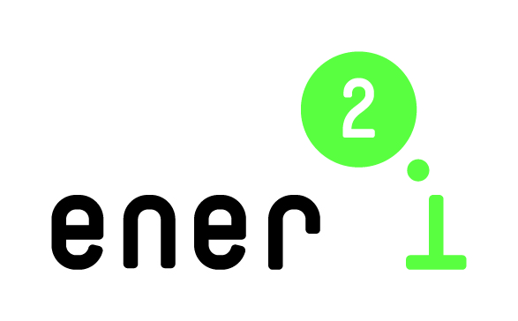 |  | 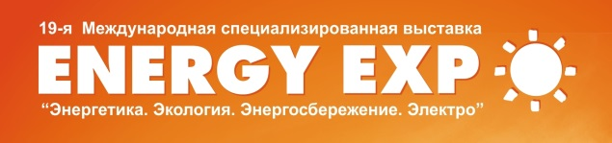

ener2i – energy research to innovation:
Reinforcing cooperation with Eastern Partnership countries on bridging the gap between energy research and energy innovation

Innovation in Energy Efficiency and Renewable Energy
ener2i Training Workshop

DRAFT AGENDA

Date: October 15, 2014

Venue: 59 Pobediteley ave., Minsk, Belarus, Viktoria Hotel, 2nd floor

09.30–10.00 | Registration
10.00–10.10 | Opening and welcome (TBC)
Part 1: General aspects of innovation in energy efficiency and renewable energies

Moderators: Manfred Spiesberger, Centre for Social Innovation, Austria
Olga Meerovskaya, Belarusian Institute of System Analysis and Information Support of S&T Sphere, Belarus

10.10–11.00 | Policies, drivers and barriers for innovation  - Knowledge societies and demands for the environment  - Factors driving and impeding in innovations for renewable energy  - Policies aiming at renewable energy in the EU and US  Yoram Krozer, University of Twente, Netherlands
11.00–11.15 | Coffee break
11.15–12.15 | Financing of innovations in energy efficiency and renewable energies: the example of Germany  - Financing instruments  - Examples from Germany  Julian Schoenbeck, EnergyAgency.NRW, Germany
12.15–12.45 | New approaches to innovation  - Open Innovation  - Social innovations, in particular in the energy field  - EU innovation policy  Manfred Spiesberger, Centre for Social Innovation, Austria
12.45–13.00 | INNOVER-EAST: cooperation in energy efficiency  Klaudia Tvergyak, Bay Zoltán Nonprofit Ltd. for Applied Research, Hungary
13.00–13.45 | Lunch break
Part 2: Innovation in specific topics of energy efficiency and renewable energies

Moderators: Alexei Dick, BelISA (TBC)
Michael Narodoslawsky, Graz University of Technology, Austria (TBC)

13.45–14.45 | Energy technology networks for smart cities  (TBC)  Michael Narodoslawsky, Graz University of Technology, Austria
14.45–15.00 | Coffee break
15.00–15.45  15.45–16.30 | Green buildings and sustainable urban design: methods and practices  Gintaras Stauskis, Vilnius Gediminas Technical University, Lithuania  Energy efficient building – pre-design aspects  Kęstutis Valančius, Vilnius Gediminas Technical University, Lithuania
16.30 | Closing remarks

Each session will combine a presentation by a speaker, as well as short interventions by participants and discussion. A session will last approximately for an hour.

Language – English, Russian. Simultaneous translation will be provided.

