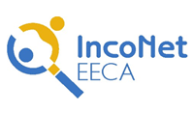

S&T International Cooperation Network
for Eastern European and Central Asian Countries

Workshop in the Thematic Priority of FP7 “Information
and Communication Technologies”
Minsk, Republic of Belarus
May 17-18, 2010

PARTICIPATION FORM

Please complete this form and send it by 16 April 2010
to Mrs. Olga Meerovskaya, email meerovskaya@fp7-nip.org.by

Last name |  | First name
Institution
Position
Experience in EU Framework Programmes
Address
City |  | Country
Tel. |  | E-mail
Fax |  | Website
Passport |  | Citizenship
Issued |  | Date of birth
Valid

Please enclose a three page (max.) CV describing your research experience.

