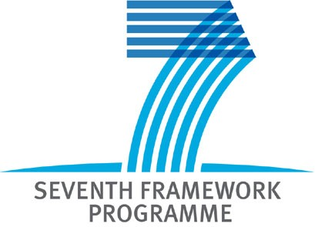

EU FP7 ICT Programme: New Opportunities for International Cooperation

Organizer: Belarusian Institute of System Analysis and Information Support of Scientific and Technical Sphere
The two-days FP7 Training and Networking event will take place within the framework of the SCUBE-ICT Project: “Strategic Cooperation in Ukraine, Belarus and EU in Information and Communication Technologies”

Draft Agenda

Thursday, 18 May 2010 - Hotel PLANETA

Training session: “Joining the EU programmes as a Belarusian”
By SCUBE-ICT partners and EU experts

9:00-9:30 Registrations

9:30-11:00 Part I: General introduction to FP7
Bent Egebart (DK)& Giles Brandon (UK)
FP7 - general
What is a Framework, the 4 specific areas, and some highlight on each one, Workprogrammes, the background documents and the programmes dynamic behavior.
Calls
Extracted from the Work Programme, not all objectives each time, look at the call fiche, to describe the objectives, the money, the type of project possible.
Proposal setup (consortium)
Complement versus supplement, rules, roles and balance within the consortium
Exercise/questions to be answered about the proposal setup

11:00-11:15 Coffee Break

11:15-13:00 Part II: Preparing and managing a successful FP7 proposal step by step
Bent Egebart (DK) & Giles Brandon (UK)
Proposal writing
Walk through the proposal basis
Part A and Part B
A step by step going through all needed kind of information, text, figures and drawings
Focus on evaluation issues (exercise)
The evaluation process, the related scheme, how to formulate the needed information.
Exercises on formulation of the needed information
Rules (general, depend of the call or the programme etc.)
General rules and rules setup in a specific objectives
Financial (budget, and funding scheme and the payment)
How does a full budget look like and what do you have to submit to it

13.00-13.30 Launch break

13.30-15.00 Part III: Preparing and managing a successful FP7 proposal step by step (cont.)
Bent Egebart (DK) & Giles Brandon (UK)

Strategies for a BY organisation (several cases presented in a step by step way, and explanation of exercise)
- How should I act to get involved in a EU project (coming from BY)?
- What to do if I have an idea to a proposal
- What to do if I only have a wish to participate within a specific area
/objectives
- How to read the WP in one of the above situations
- How to get involved with the Commission, PO, evaluation, meetings etc.

Exercise and presentation
4 groups have to formulate a strategy to be followed by a BY organisation (some guidelines will be given and there will be several options to chose for the groups)

15:00-15:15 Coffee Break

15.15-17.00 Part IV: Useful information, links, facilities
Bent Egebart (DK) & Giles Brandon (UK)

Marie Curie and ERA-WIDE (program, call and benefits, examples)
ICT 2011-12 programme and calls
Learn how to read a WP and do some temporally planning
Information days, nationally and internationally
How to react, how to chose, how to participate and where to find them
Main errors in proposals
Lesson learned at the Commission in February (2 important ones and several others)
Cordis facilities
Showing how to find ongoing projects*
FP7 NCP, FP7 Support Actions (SCUBE-ICT, EXTEND including Helpdesk, ISTOK-SOYUZ and IncoNET EECA)
Partner search facilities (practical examples including Idealist)
Presentation of the use of Ideal-ist and maybe some examples on others(?)

Exit evaluation questionnaires

17:00 Closure of the day

