  EXTEND | 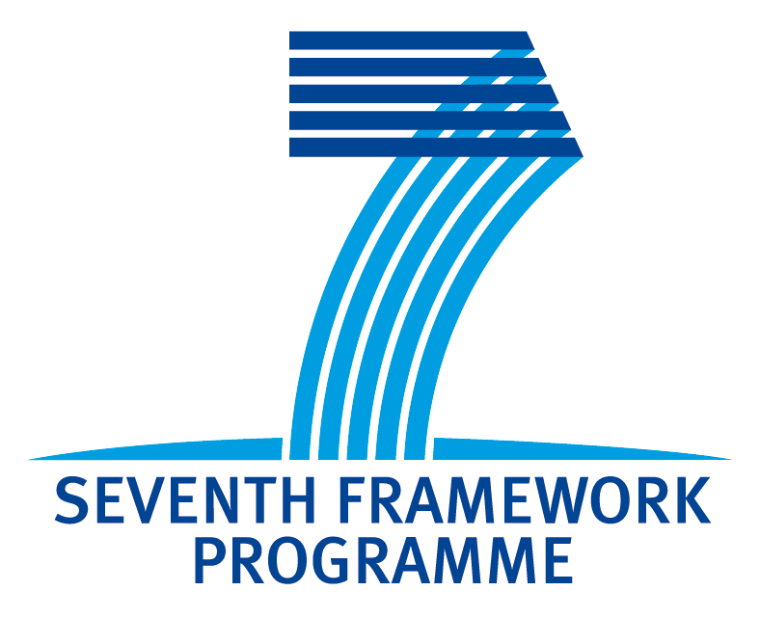 | 

EXTEND Training Workshop

Your idea for a Framework Project:

Consider the objectives of Call 8/9 of the ICT Work Programme 2011-2012 (if you can’t match your activities with open objectives use any of the available ones in the work programme). What would you ideally like to propose for a project?
Briefly describe your idea from a technical point of view, keeping in mind that the topic should be in line with the activities of your organisation and their available skills and also be of relevance for both your country and Europe.
Please address
- business, societal and technological drivers of your idea,
- implementation details i.e. required skills- possible profile of partners ,
- time, resources, etc,
- and expected impact with respect to EC’s requirements.

NOTE: PLEASE READ THE ICT WORK PROGRAMME 2011-2012 CAREFULLY BEFORE DRAFTING YOUR IDEAS

PROPOSAL AT A GLANCE

Proposal name:

Subject:

PROJECT DESCRIPTION

Proposal Outline:

Keywords:

PARTNER PROFILE SOUGHT

Required skills and Expertise:

Description of work to be carried out by the partner(s) sought:

Type of partner(s) sought:
EXPECTED IMPACT WITH RESPECT TO EC’s REQUIREMENTS

